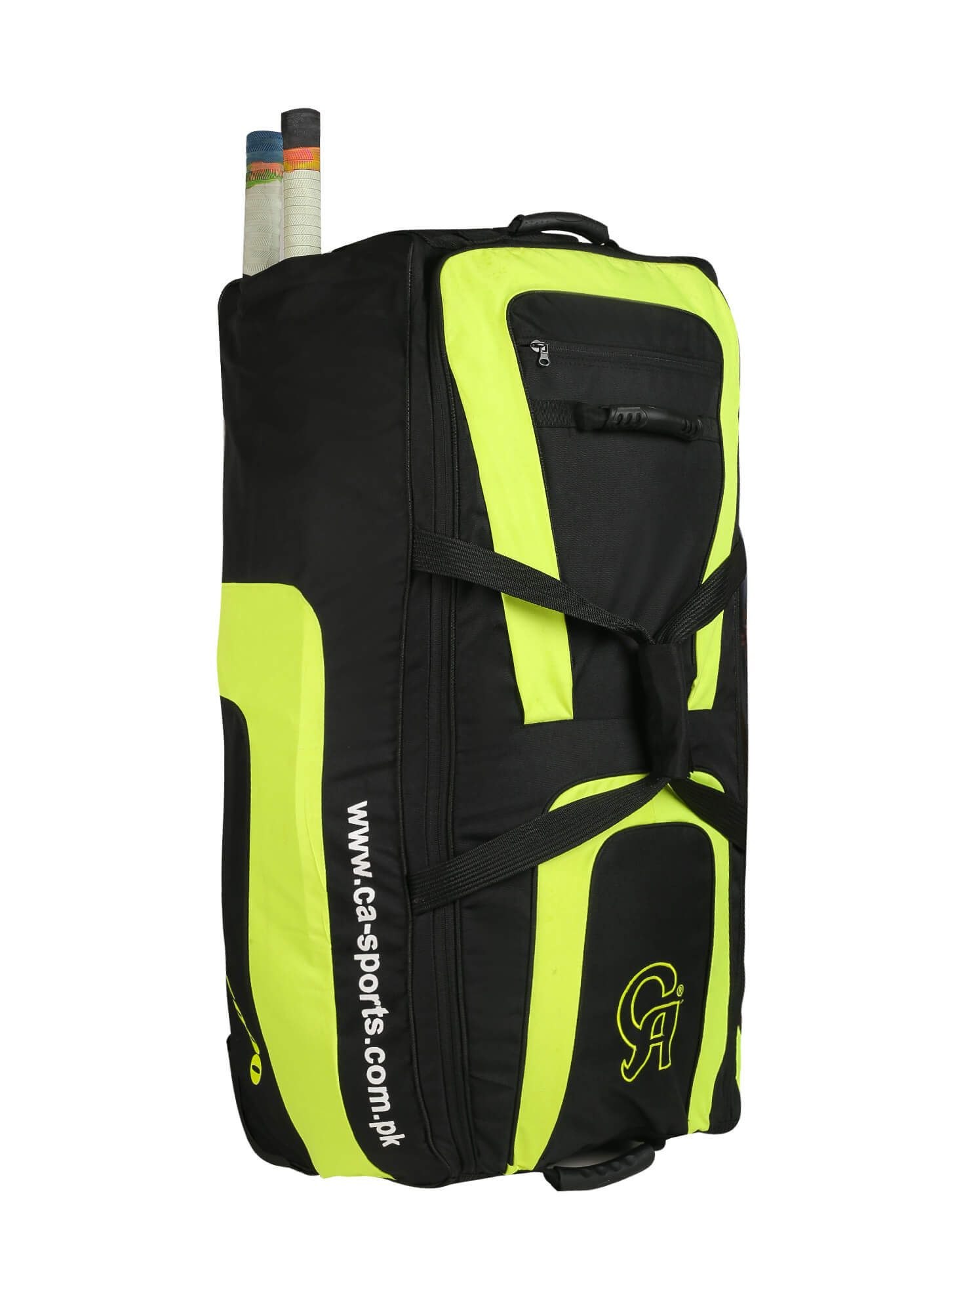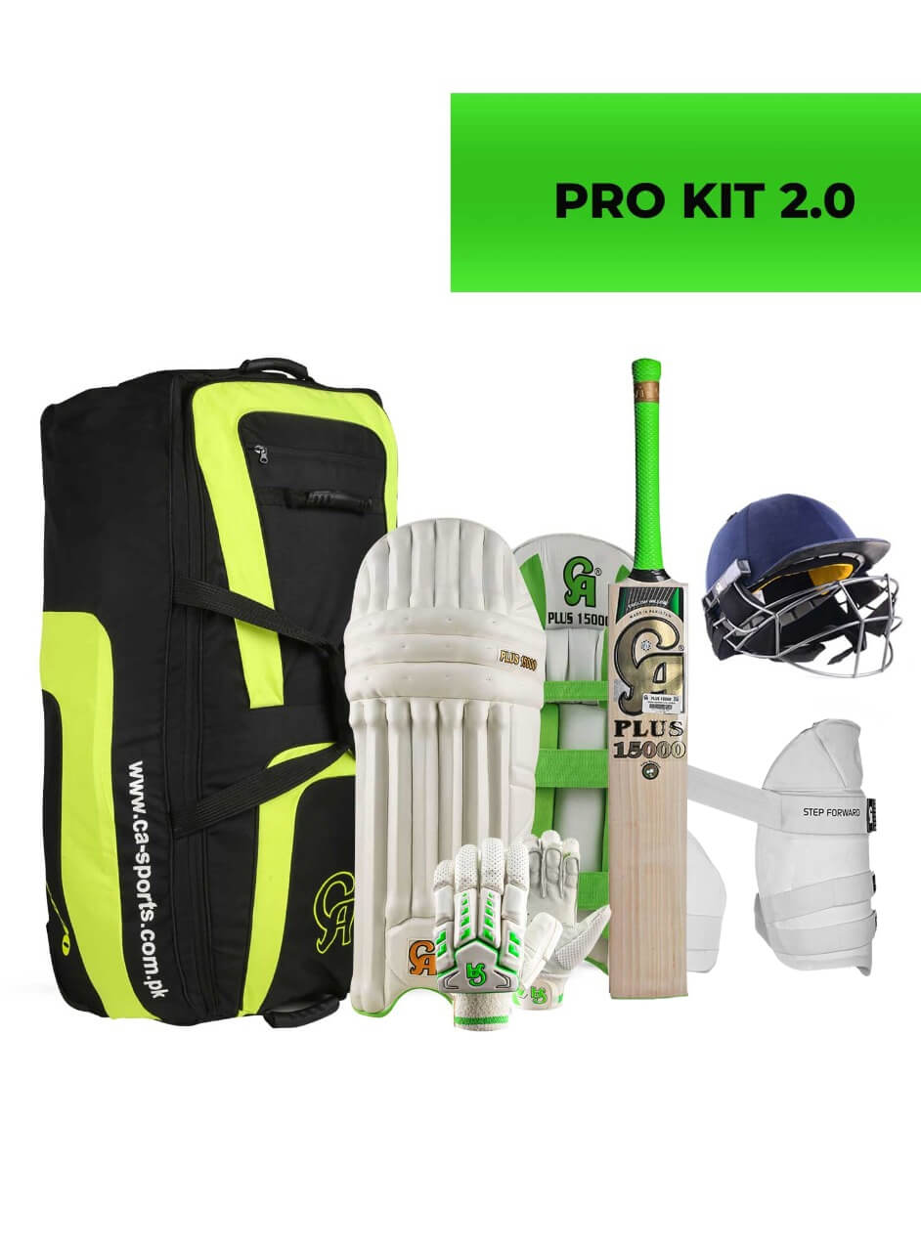

CA SPORTS PRO-KIT 2.0

Great Idea with no delay. CA Intermediate Kit is out for all the beginner to the intermediate level batsmen to be dominant and protected on the field. Plus 15000 products with SM-18 Helmet is complete kit along with super famous plus 15000 cricket bat. Saving is a plus on the deal.

**DETAILS:**

* Plus 15000 batting pad
* Plus 15000 bat
* Plus 10000 thigh guard
* Plyer Edition bag
* Players Edition Batting Gloves
* SM-18 Helmet